Animal Magic

Our theme for this half term is Animal Magic! We will be learning about animals that live on the farm, in the jungle, safari and minibeasts! Here are some activities you can do at home to continue your learning:
Find an old toilet roll tube and some craft resources. Turn your toilet roll tube into your favourite animal!  You could make a penguin, a lion or even a snake!  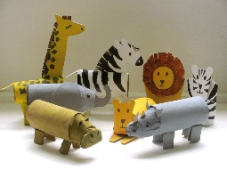 | Read 3 books that have animals as the main characters. | Make these snacks that look just like the tracks animals leave behind. https://www.loreenleedy.com/blog/2018/3/24/animal-tracks-snacks
Make a list of lots of different animals you know. Think about how many legs these animals have. If you have the animals as a toy you could count the legs or look up pictures in books or on the internet. You could make a list and record your findings. | Draw a picture of your favourite zoo animal.  Have a go at copying an adult’s writing to write the name of the animal you have drawn. | Follow along with Jaime, doing some Yoga to a jungle themed story:  https://www.youtube.com/watch?v=C4CaR0syf1g

