**Bishop Lonsdale Primary School and Nursery**

**Active World Primary – Parent’s Guide**

Go to the Active Learn Primary home page. <https://www.activelearnprimary.co.uk/login?c=0>

Click on ‘Log In'.

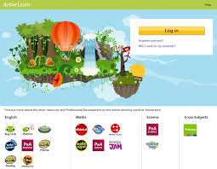

Find out your Username and password by e-mailing [homelearning@bishoplonsdale.derby.sch.uk](mailto:homelearning@bishoplonsdale.derby.sch.uk) or from your teacher on the class home learning address.

Enter your username, password and the school code. **The school code is 7rqm**.

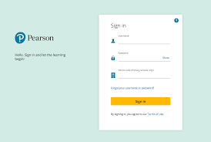

This will take you to the home page. Your child can change their home screen by hovering over the ‘My Home’ tab at the top of the screen. They can choose bug, race or future world. To read a book and earn some active coins click on ‘My Stuff’, then ‘Independent’ and you will see a list of books that your child can read. The books have been set by your child’s class teacher.

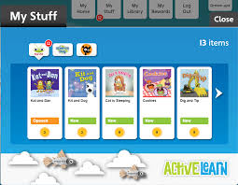

To open a book just click on the one your child would like to read and it will open. You can choose to have the book read to your child or they read it themselves.

Throughout the book are ‘bugs’ to click on, answer questions to earn active coins. When the bug questions have been answered, return to the book to complete reading it.

Some bugs require a written response which teachers can see and mark. At the end of the book you will be able to see if all bugs have been answered. When the book has been read and the questions answered the book will move to ‘My Library’.

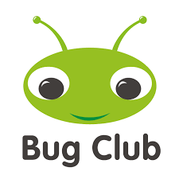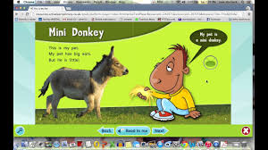

In addition to the independent reading your class teacher may have added other tabs such as spelling and grammar or science. Coins can also be earnt in some of these activities.

There are often videos with activities to help you and your child know what to do.

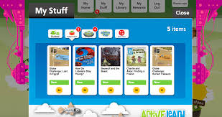

Other tabs such as grammar and spelling.

In ‘My Library’ you will find the books that your child has already read – you can read them again if you wish too. You don’t earn any more coins though.

In ‘My Rewards’ the children can choose 3 different screens to play games and spend their active coins in. They can do races in the pit stop, collect stickers in the sticker factory and add items to a tree house. Let your child explore these screens and they will soon get the hang of it.



Until we are allowed to use reading books again, this is how we are going to listen to children read at school. If your child is at school, we would still encourage you to listen to your child at home. We recommend reading just one book a day and completing the questions that match the book.

If you require any more help with Active Learn Primary’ Please do not hesitate to call school on 01332 344795 or e- mail homelearning@bishoplonsdale.derby.sch.uk